*Create User Model & Save Data In MongoDB:*

Step 1: create usermodel.js schema in model folder with properties that you want to add in table (in my case I added firstname, middlename, lastname & email) as show below screenshot.

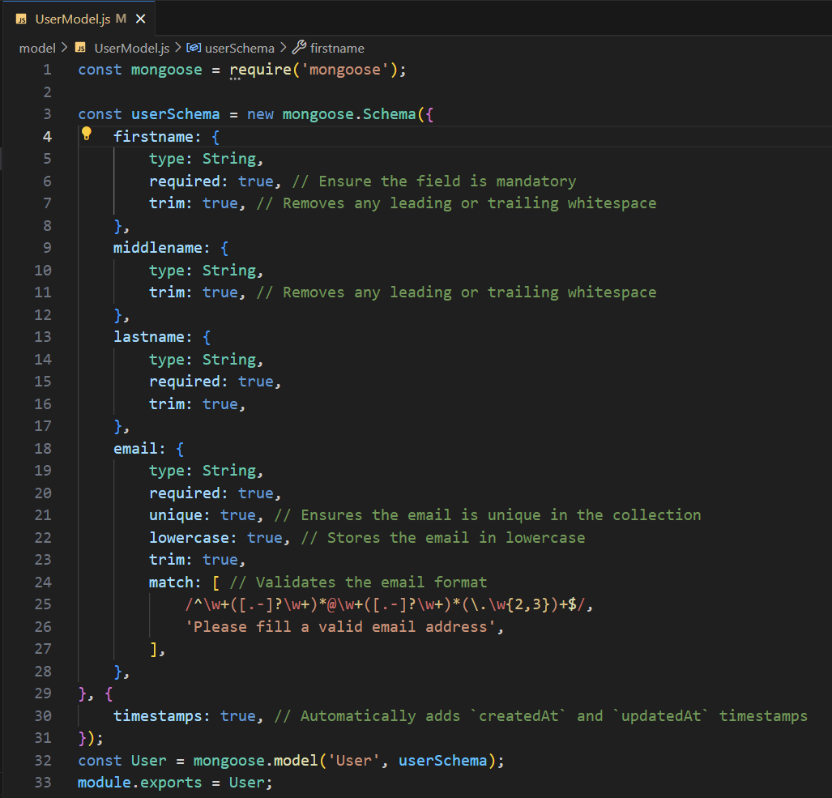

Step 2: In controller folder create userController.js file and create controller method for create, update, delete & get user detail as shown below screenshot.

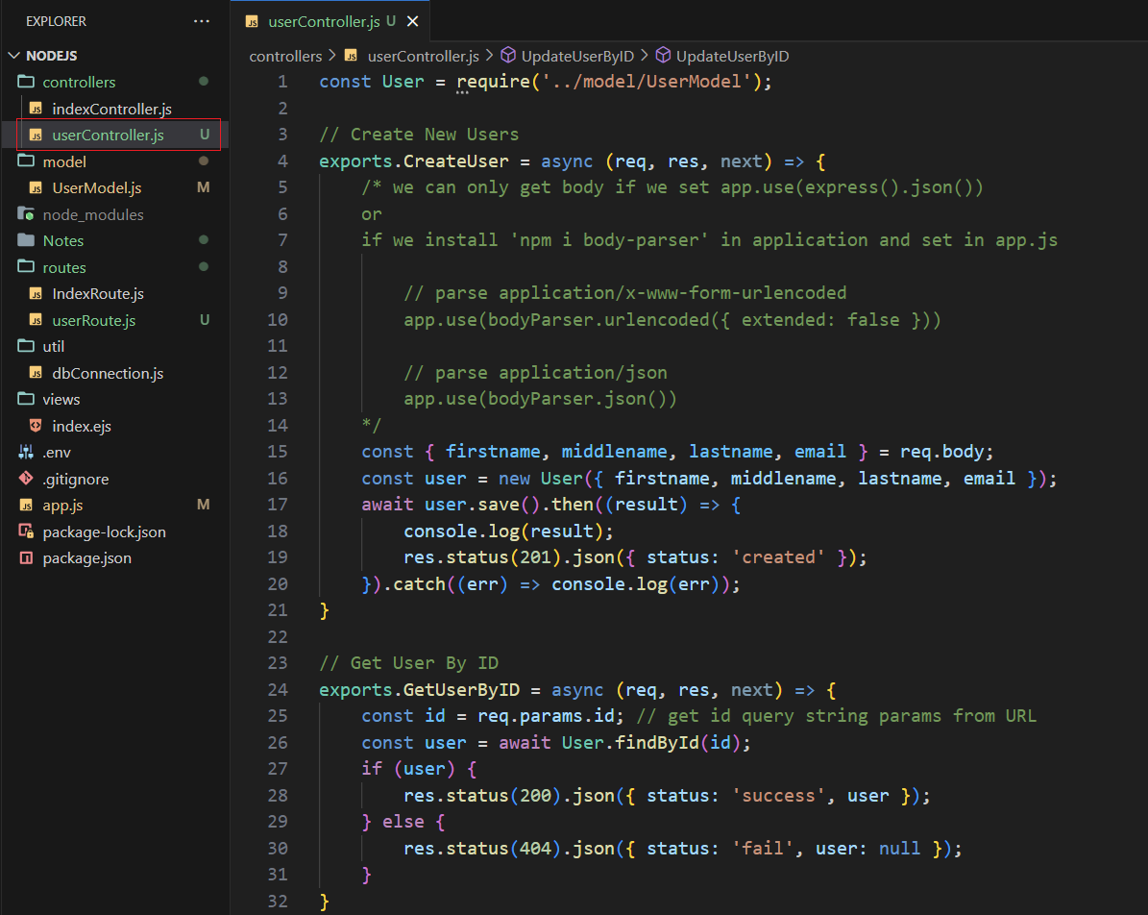

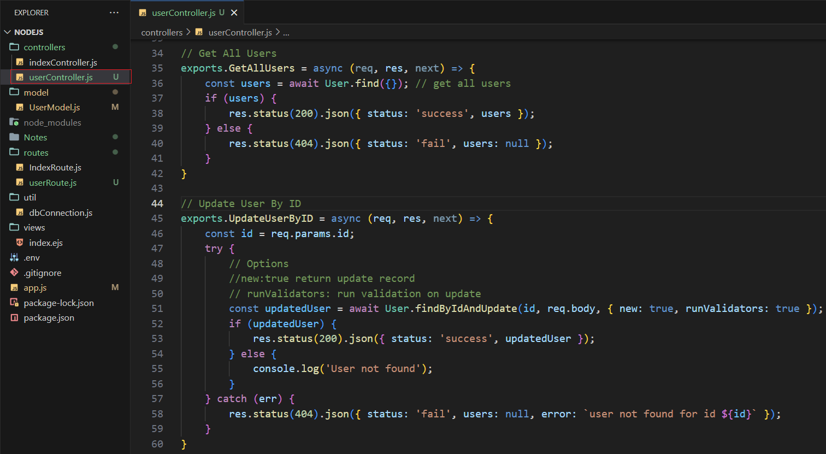

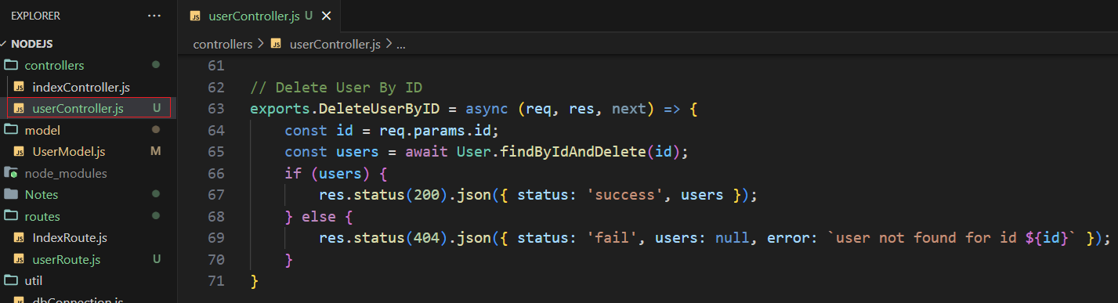

Step 3:

Now after added methods in controller we need to create routes in route folder with named userRoutes.js and add below code to add routes for create, get, post, put and delete.

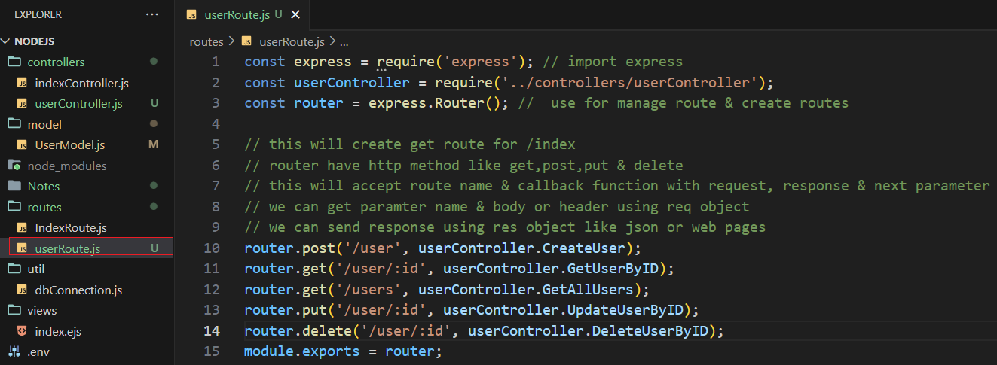

Create Cookie & Read Cookie:

